MyBnB user manual

# Start page:

* Registration
  1. Choose “Register as a new user”
  2. Complete fields E-mail, SIN, First Name, Last Name, Occupation, Birthdate(YYYY-MM-DD), Country, Province, City, Postal Code, Address, Latitude and Longitude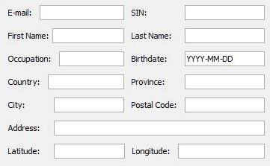
  3. Click “Register”
* Log in
  1. Choose “Log in as an existing user”
  2. Type in your unique email
  3. Click “Log in”
* Delete a user
  1. Choose “Delete a user”
  2. Type in the unique email of the user to delete
  3. Click “Delete”

# User page:

* To view credit Cards you have added to your account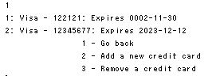
  1. Enter 1 in the command line and hit Enter
  2. Enter 1 again to go back to home page
  3. Enter 2 to add a new credit card
  4. Enter 3 to remove an added credit card
* To view listings you host 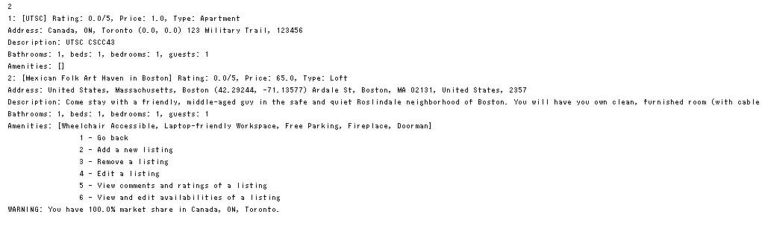
  1. Enter 2 in the command line and hit Enter
  2. Enter 1 again to return to home page
  3. Enter 2 to add a new listing
  4. Enter 3 to remove a listing you added
  5. Enter 4 to edit a listing
  6. Enter 5 to view the comments and ratings of a listing
  7. Enter 6 to view and edit availabilities of a listing (warning: this option will be unavailable, if you wish to edit it for the period it has been booked, you can edit it after the booking is completed, or cancel the booking on your end, and then edit it.)
* To view comments your hosts have put on your profile
  1. Enter 3 in the command line and hit Enter
* To view ratings you have received
  1. Enter 4 in the command line and hit Enter
* To view the current listings you have booked
  1. Enter 5 in the command line and hit Enter
* To search listings, enter 6
* To Exit application, enter 7 in the command line

# Reports:

* Find number of Listings per Country in the database
  1. Click “Number of Listings per Country”
* Find number of Listings per Postal code
  1. Click “Number of Listings per Postal Code”
* Find number of Listings per City
  1. Click “Number of Listings per City”
* Find Hosts who use MyBNB commercially for profit
  1. Click “Find Commercial Hosts”
* Rank Hosts by Country
  1. Click “Rank Hosts by Country”
* Rank Host by City
  1. Click “Rank Host by City”
* Rank Cancellations by Host
  1. Click “Rank Cancellations by Host”
* Rank Cancellations by Renter
  1. Click “Rank Cancellations by Renter”
* Rank Renters in a specific Date Range
  1. Enter Start Date and End Date
  2. Click “Rank Renters in Date Range”
* Rank Renters by City in a specific Date Range
  1. Enter Start Date and End Date
  2. Click “Rank Renters by City in Date Range”
* Rank Bookings by City in a specific Date Range
  1. Enter Start Date and End Date
  2. Click “Rank Bookings (City) in Date Range”
* Rank Bookings by Postal code in a specific Date Range
  1. Enter Start Date and End Date
  2. Click “Rank Bookings (Zip) in Date Range”
* Get popular words used to describe the experience at each Listing by users
  1. Click “Get Word Clouds”

# Search

* To search listings
  1. Enter 6 in the command line and hit Enter
  2. You will be diverted to the Search UI, look in page 4
  3. 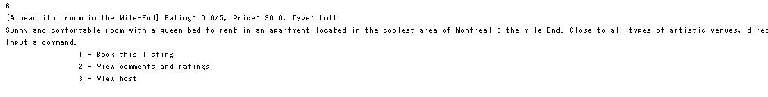Once you select the listing you wish to book, you will be taken back to the command line
  4. Enter 1 to book the chosen listing
  5. Enter 2 to view comments and ratings by previous renters (or you can comment and rate it if you have rented the listing within the past 3 months)
  6. Enter 3 to view details about the host
* Search by Co-ordinates
  1. Choose “Search by Co-ordinates”
  2. Enter Latitude, Longitude, Vicinity
  3. Click “Start Search”
* Search by exact Address
  1. Choose “Search by exact Address”
  2. Enter exact address, and optional values number of beds, number of bedrooms, number of Bathrooms and maximum number of guests
  3. Click “Start Search”
* Search by adjacent Postal Codes
  1. Choose “Search by adjacent Postal Codes”
  2. 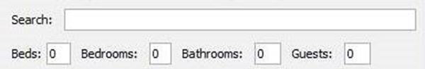Enter a postal code
  3. Click “Start Search”
* Sort
  1. To sort by Price choose “Sort by price(Ascending)” or “Sort by price(Descending)”
  2. You can also enter optional information such as, Date range start, Date range end, Price range max and Price range max to filter according to your preference. You can also select Amenities on the left side box.

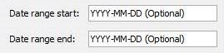



* 1. Click “Start Search”